JĘZYK ANGIELSKI – 3-4 latki

SŁÓWKA:
DAILY ROUTINES – CODZINENE CZYNNOŚCI
• GET UP – WSTAWAĆ
• TAKE A SHOWER – BRAĆ PRYSZNIC
• HAVE A BREAKFAST – JEŚĆ SNIADANIE
- GET DRESSED – UBIERAĆ SIĘ
- BRUSH YOUR TEETH
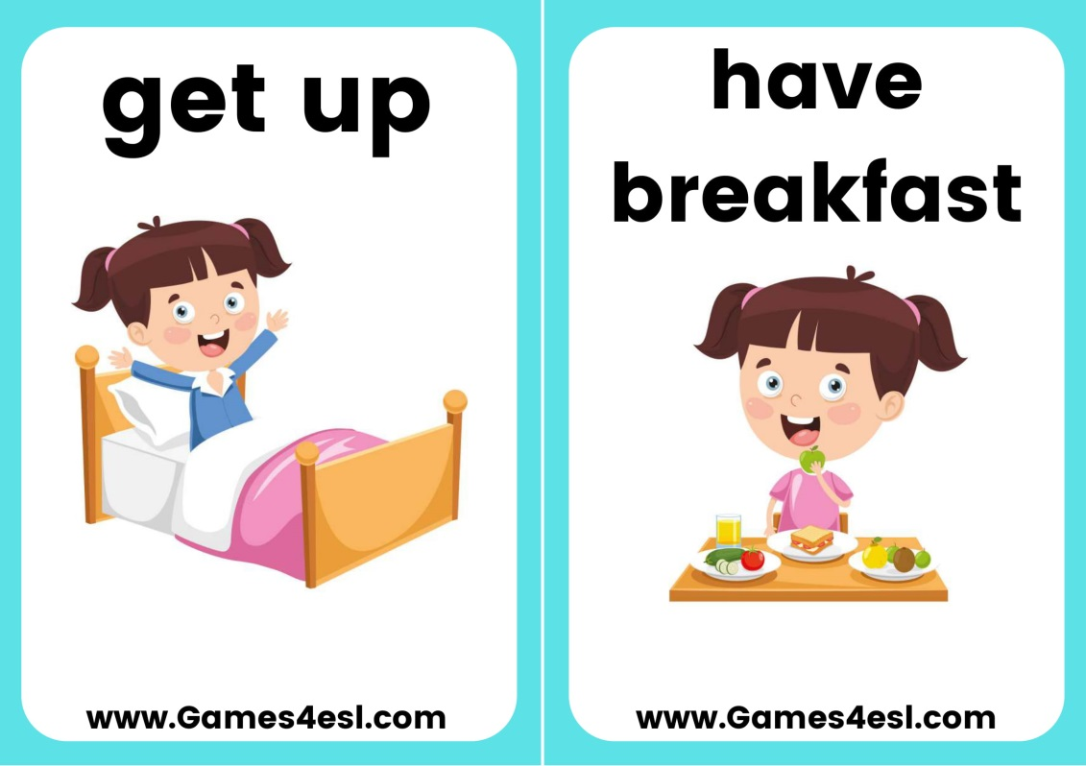

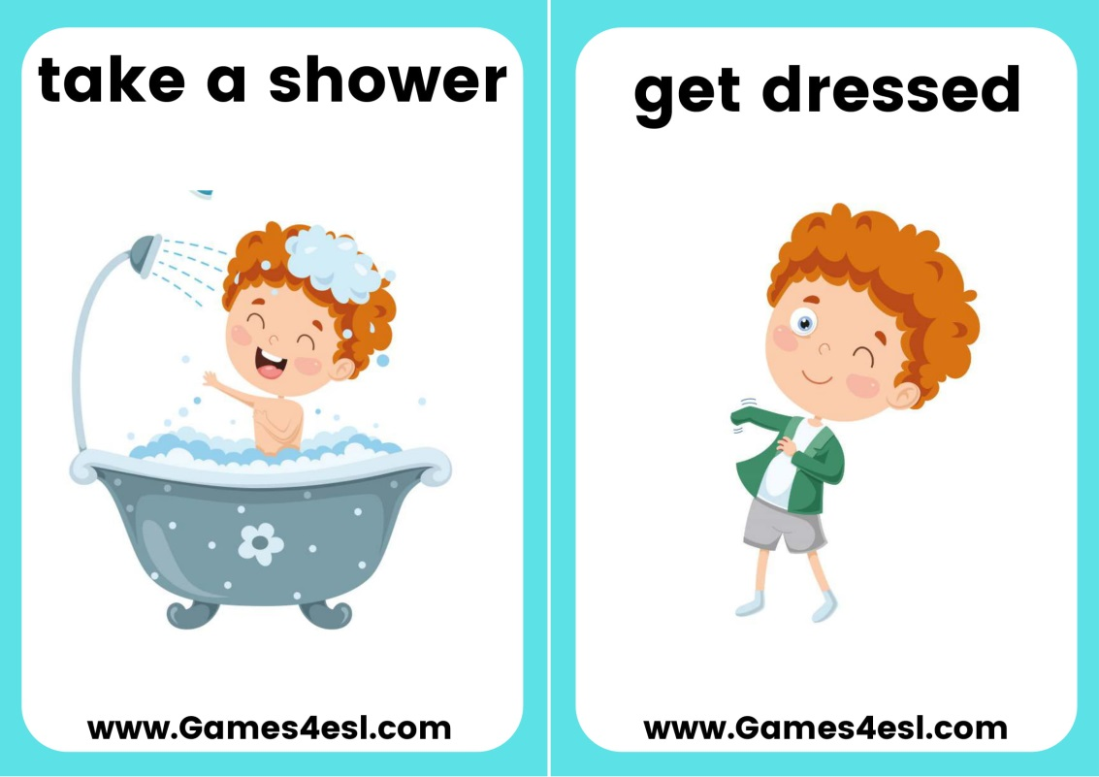
Link do piosenki Brush your teeth - https://supersimple.com/song/brush-your-teeth/
Brush your teeth up and down.
Brush your teeth round and round.
Brush your teeth from left to right.
Brush your teeth in the morning and night.

Brush brush brush.
Brush brush brush.
Brush your teeth in the morning and night.

Brush your teeth to keep them white.
Brush your teeth so your smile is bright.
Brush your teeth. It’s so much fun.
Brush your teeth when the day’s begun.

Brush brush brush.
Brush brush brush.
Brush your teeth when the day’s begun.

Brush your teeth, just open wide.
Brush your teeth from side to side.
Brush your teeth you sleepy head.
Brush your teeth before you go to bed.

Brush brush brush.
Brush brush brush.
Brush your teeth before you go to bed.

